INDIGENOUS SERVICES CANADA
SHELL CASE MANUAL

1138 Melville St Suite 600,
VANCOUVER BRITISH COLUMBIA
V6E 4S3
Phone: 778-951-0716 / 1-855-JP-CHILD (1-855-572-4453)
Fax: 604-775-7149

Issue 3

Amending Procedures and Distribution List
  - Amending procedures
The Shell Case Manual is an Indigenous Service Canada approved document and shall be reviewed once a year in January and amended as required. The manual shall be amended to incorporate any relevant changes to policies and procedures. Black change bars in the margin indicate a change in the text or tables for the current revision of that page only. The change bars are omitted at the next revision of that page.
All amendments are effective upon receipt. All manual holders must review the changes prior to use to ensure that operations are conducted in accordance with the most current procedures and directives. All amendments will be incorporated on GCDocs in the controlled documents section. Every attempt will be made to ensure the uncontrolled documents section is up to date however, only controlled documents may be used by operational personnel for the performance of their duties.
  - Bulletins
Bulletins contain time critical information that is generally effective until revisions are produced. Any bulletins issued for the Shell Case Manual must be approved prior to release; this function is the responsibility of the Operations Manager, Jordan’s Principle and The Inuit Child First Initiative. These bulletins are considered mandatory and must be read upon receipt. Bulletins are placed on GCDocs and are available for all applicable operational personnel. Bulletins will also be incorporated in the controlled copy of the Shell Case Manual on GCDocs and will be placed in the front of all printed controlled manuals.
  - Shell Case Manual Distribution and Control
The Operations Manager, Jordan’s Principle and The Inuit Child First Initiative is responsible for maintaining a master list of manual holders and for controlling the distribution of these manuals. This function has been delegated to the Program Assistant under the direct supervision of the Operations Manager.

AMENDMENT REVISION RECORD SHEET

Amendment Number | Entered By | Date Entered
1 | Emily Smith | 2/22/2022
2 | Avneet Thukral | 4/25/2022
3 | Emily Smith | 5/10/2022
4 | Emily Smith | 6/17/2022
5 | Emily Smith | 7/4/2022
6 | Emily Smith | 7/8/2022
7 | Emily Smith | 8/5/2022
8 | Celina Santilli-Giza | 27/9/2022
9 | Austin Chan | 10/26/2022
10 | Austin Chan | 12/6/2022
11 | Austin Chan | 12/22/2022
12 | Emily Smith | 6/5/2022
13 | Emily Smith | 7/4/2022
14 | Austin Chan | 7/10/2023
15 | Emily Smith | 10/6/2023
16 | Emily Smith | 11/6/2023
17 | Emily Smith | 11/15/2023
18 | Joyce Fan | 04/16/2024
19 | Emily Smith | 6/28/2024
20 | Joyce Fan | 08/22/2024
21 | Emily Smith | 11/1/2024
22 | Chido Achimole-Ibe | 05/27/2025
23 | Emily Smith | 08/05/2025

Contents
Amending Procedures and Distribution List 2
0.1. Amending procedures 2
0.2. Bulletins 2
0.3. Shell Case Manual Distribution and Control 2
AMENDMENT REVISION RECORD SHEET 3
INTRODUCTION 6
SHELL CASE CREATION 6
Initial Settings – GC Case 6
Initial Settings – Outlook 7
Beginning a New Request 7
Non-time sensitive requests 8
Time Sensitive Requests 9
Case Creation 11
Requestor 11
Required Data 12
Adult Participants 12
Child Participant 13
Items 17
Child-Item-Needs 19
Upload Document Package 20
Incomplete Request Post 22
Assign 23
Adding New Items to Existing Pending Cases 24
GROUP REQUESTS 27
NCC REQUESTS 28
Acknowledgement of reciept 29
Appendix 1. AOR Template – Non-Time-sensitive Requests 31
Appendix 2. AOR Template – Time-sensitive Requests 32
Appendix 3. AOR Template – NCR Cases 33
Filling out the Acknowledgement of Receipt Notification on GCCase 34
Notification of Decisions For ESCALATED CASES 36
Duty Phone aka Client Support Phone 38
APPENDIX A – Relevant Hyperlinks 42
Appendix B - ISC BC Region Contact Info 43
APPENDIX C: CLIENT SUPPORT PHONE TEAM 43
APPENDIX D – SHELL CASE FROM A FILE REVIEWER’S PERSPECTIVE 44
Appendix E - Process for Incomplete Requests 50
APPENDIX F – How to Exit Items and other Superuser Processes 52

INTRODUCTION
Jordan's Principle makes sure all First Nations children living in Canada can access the products, services and supports they need, when they need them. Funding can help with a wide range of health, social and educational needs, including the unique needs that First Nations Two-Spirit and LGBTQQIA children and youth and those with disabilities may have.
The Shell Case Team is responsible for inputting applications received by the requestors into GCCase, the software used by Jordan’s Principle. One of the first steps to case creation is to ensure the employee has access to all the resources required. Make sure you have acquired access to the following programs (speak with your manager or trainer if you don’t).
- GCCase
- GCDocs
- Foxit PDF Editor
- IRS
- Principe de Jordan CB – BC Jordan’s Principle Inbox (New Request Folder)

SHELL CASE DATA ENTRY PRIORITIES

(last updated Sept 29, 2055) The data entry priority order for Shell Case Team is:

- Directly Assigned Urgents (these come to your email, check often)
- Group Requests (try to get folder to 0 by EOD)
- New Request, Time Sensitive Request, and Non CHRT Urgent request folders based on oldest date of oldest email across the three folders.

SHELL CASE CREATION

Initial Settings – GC Case
By default GC Case works in Eastern Standard Time. We need to change this otherwise all the time we input will be incorrect. When logged into GC Case press the ‘cog’ on the top right of the page and select ‘options’. From the drop down menu select ‘Pacific Time’ and set your default currency to ‘Canadian Dollar’.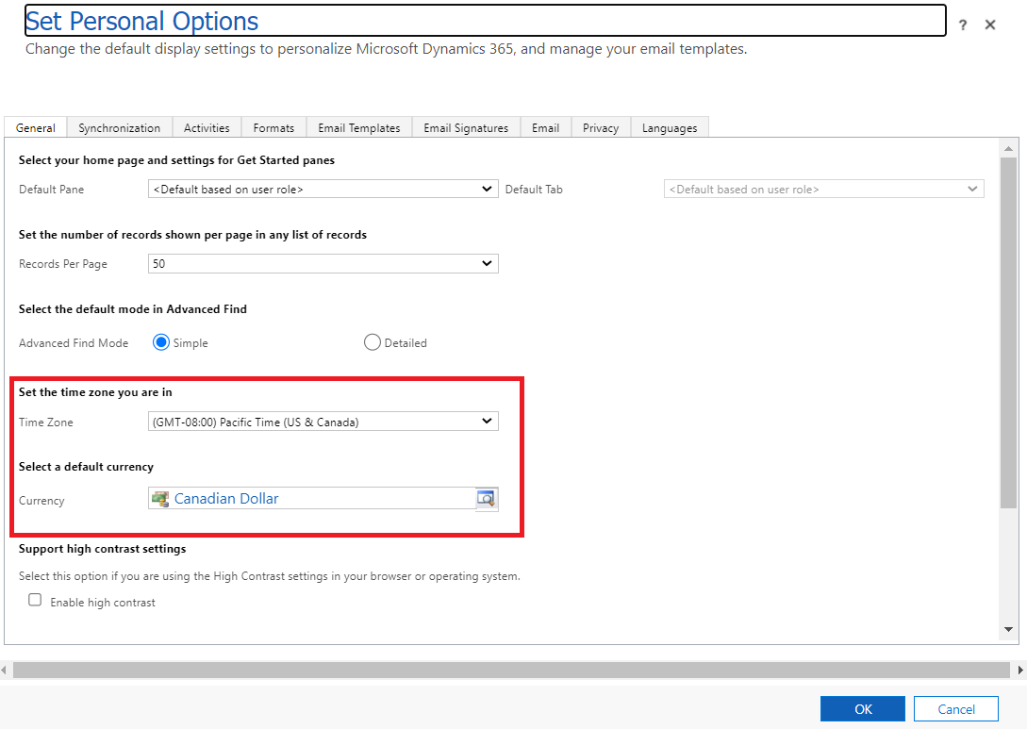

Initial Settings – Outlook
Next we want to change our read settings in Outlook. We work within a shared inbox with other members of the Shell Case Team. To avoid confusion, we want to stop Outlook from automatically marking emails as read.
In Outlook, click on the ‘View’ tab, then ‘Reading Pane’, and select ‘Options’. Uncheck the below options. This will prevent Outlook from automatically marking emails as read when you click on them.
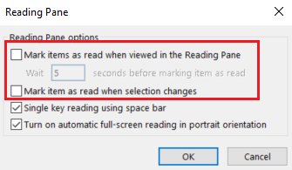

Access to the shared New Request folder should be granted by the manager/custodian as part of the onboarding process. We still have to add the folder to our Outlook manually in order for it to show up.
In Outlook press the ‘File’ tab, from there select ‘Account Settings’ and ‘Account Settings’ again. Go into the ‘Data Files’ tab and select ‘Settings’ and ‘Advanced’. Finally, press ‘Add’ and type in “Principe de Jordan CB - BC Jordans Principle” Press ‘OK’ to add the mailbox to your Outlook and it should now show up. Within the Main Inbox you should see the ‘New Request’ Folder.
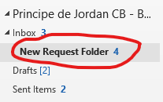

Beginning a New Request
Requestors submit their Jordan’s Principle Request Forms to our general inbox: ‘Principe de Jordan CB - BC Jordans Principle (SAC/ISC) sac.principedejordancb-bcjordansprinciple.isc@canada.ca’. An intake officer will review the incoming request and classify the request as either ‘Time Sensitive’ or ‘Not Time Sensitive’ (and very occasionally ‘urgent’).

Non-time sensitive requests
All non-time sensitive requests will then be forwarded to the ‘New Request’ Folder. Once in the New Request Folder, we input the information into GC Case, thus creating a shell case.
To begin, first flag the request that you will be working on. This lets other members of the team know that the request is being worked on, preventing people from creating duplicates. When completed, mark the request with a check mark.
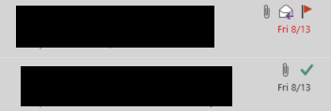
After reserving your request, the next step is to save all relevant documents. Right-click or press the drop down menu on the attachment and select ‘Save-All Attachments.’ Next we need to save the incoming email. While the email is opened, go to ‘File’ and then ‘Save As’. We will have to compile all the documents into one PDF package.
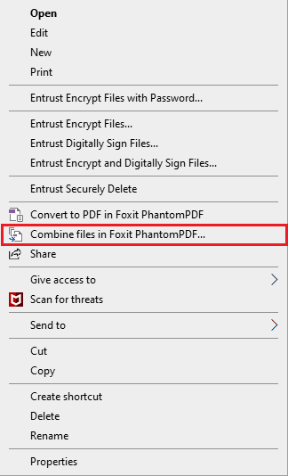
We use Foxit PhantomPDF to compile all the documents into a single PDF package. Highlight all the saved documents and emails and then right click and hit ‘Combine into PDF’

While combining the files you are given the option to re-arrange the order of the documents. The specific order for combining is:
- To have the request form at the beginning of the package
- Service coordinator Notes
- Support Letters
- Assessments
- Pictures
- Quotes
- Any other supporting documents necessary
- The incoming email at the end of the package

This allows the package to be more convenient for the Focal Point/File Reviewer. The documents in between have no set order but try to keep similar documents together (i.e., invoices, assessments, letters of support, etc.).
Name the file as “[Child’s Name] Initial Application Package”
Before we start inputting the information into the system we must first check for existing duplicates. Sometimes requestors may send the application twice, and sometimes requestors submit additional information for an existing case that may seem like they are submitting a new application.
On the top right hand of GC Case you will see a magnifying glass. Use this to search the child’s name. You can open the existing case and see if the reason for request is the same. If they are different then you can proceed with creation. If they are the same, check the uploaded files/dates/items to see if they are identical.

After checking GC Case, we have to check GCdocs to see if there are any existing cases there. Prior to GC Case, Jordan’s Principle used GCdocs to store documents. Use the search function on the top right to search for the child’s name. Chances of cases here being duplicates are highly improbable as they were submitted years ago, but it does happen occasionally.
Old Jordan’s Principle requests in GC Docs live in the Jordan’s Principle Folder. Add this folder to your GCDocs “Favorites” or bookmark in your preferred web browser. Jordan’s Principle requests stored in GC Docs will show up in folders titled IN-BC-XXXX.
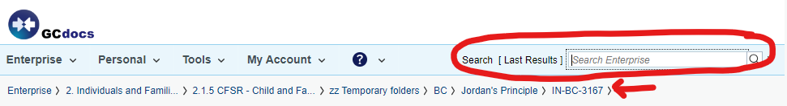
Take note of any existing cases in both GC Case and GCdocs as there is a section during case creation to input Request History.

Time Sensitive Requests
Time Sensitive requests are not sent to the New Request folder. Instead, the Intake Officer from our Inbox Team will send it to the Priority Time Sensitive Folder. If you are going to begin the time sensitive shell case then flag the email to let everyone know you are working on it. Again, this prevents duplicate cases from being created.
In the Reason for Request box, start with the words “Time Sensitive:”
In the Items box under Time Sensitivity, choose “Time Sensitive”. Under Target Date indicate if there is a start date to the request. If not, use your judgement and indicate a date as a guide the file reviewer can use to prioritize the case.
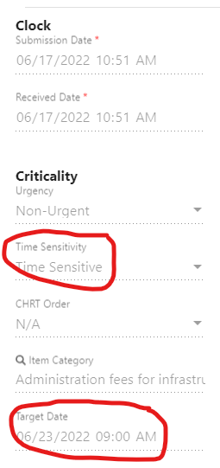

Note: Sometimes requests that should be prioritized slip past the Intake Officers and they send them to the ‘New Request’ inbox. If you start a request and you think it should be classified as time sensitive; forward it to the Jordan’s Principle email, “principedejordancb-bcjordansprinciple@sac-isc.gc.ca”, and state why you think it may be time sensitive. An Intake Officer will review it again and may re-classify the request.
The following are some criteria which is used to determine time sensitivity:
- Child is in pain
- Direct threat of apprehension by child services
- Direct threat of child being expelled/missing school
- Life-threatening
    - Eg. Pharmacy needs to disburse medication for particular deadly disease/condition, they will run out in XX days without funding
    - Eg. Child is having severe mental health issues, anything re: self-harm etc.
- Time-sensitive appointment/appointment is booked (ie. Appointment is within a month)
- Undue financial burden/financial stress is stated
- Memorial services (potlatch, travel, meals, accommodations)

Note: potential for suicide is to be deemed urgent and not time sensitive. If you think a request is urgent, always check with Inbox. NEVER create an urgent item in a shell case unless directed to do so by a PM from the Inbox team.

When the Priority Time Sensitive Shell Case is complete, the Shell Case team member sends an email to the inbox with the subject line : “Review Required T/S: ISC- #####-#### - Brief description [e.g. Medical Equipment, Assessment, Travel] - Target Date YYYY-MM-DD”

Case Creation
Once we have checked that this is not a duplicate case, we can start the creation of the shell case. To begin, click on the “+” sign on the top right corner of GCCase.


Requestor
This is where we input the Requestor information. All requests require a requestor. The requestor is the person who submitted the application (i.e., parent, social worker, teacher, etc.). If the requestor is the parent, you will find their information in Section 2 of the request form. If the requestor is an authorized representative, you will find their information filled out in Section 3 of the request form.
It is best practice to always search for existing profiles when adding participants. This allows us to prevent duplicates from being created. Before inputting the data, press on the magnifying glass that says ‘Existing Person’. Type in the participants name and click on the hyperlink to match the information. If you believe it is the same person then you can use the existing profile instead. Do the same when you get to the contact stage, as selecting a profile does not automatically add the contact information.
NOTE: for existing participants, evaluate contact information carefully. One PRS-ID may be associated with more than one contact record. Choose the contact record that most closely matches what you see on the request form and update any details if necessary.
NOTE: Jordan’s Principle Service Coordinators may have more than one contact record associated with their PRS-ID. They may have one contact record for their work, and one for their home. This is because Service Coordinators act as authorized representatives, but may also apply for their own children. Be very careful not to use a Service Coordinator’s home contact information for a case where they are acting as an authorized representative.
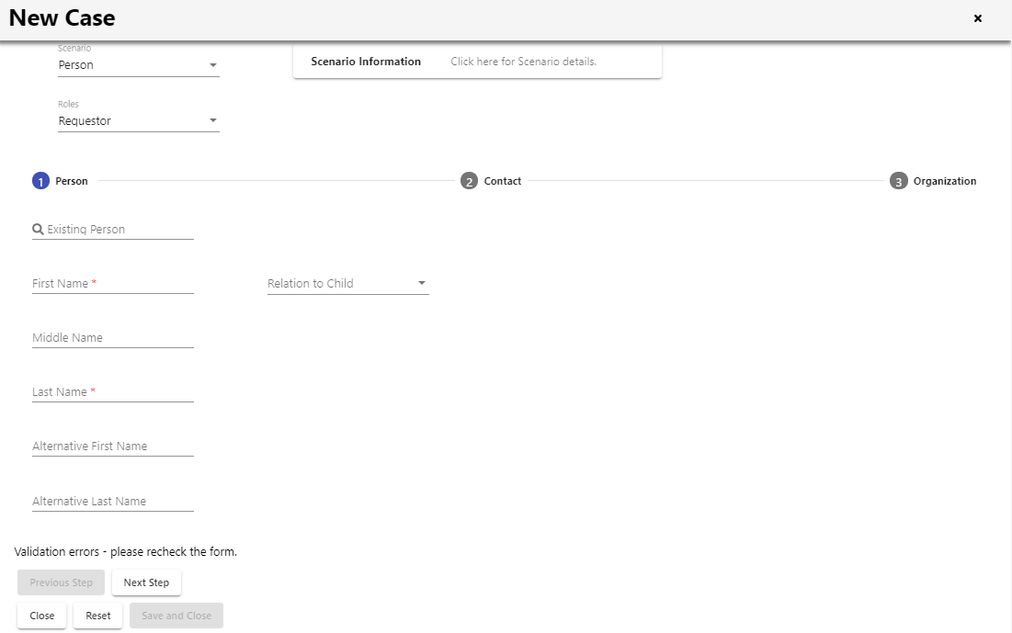
When adding a participant, you are able to select multiple roles from the drop down menu, (i.e., if the requestor is also the parent, or if the requestor is also a Service Coordinator).

Required Data
Next we enter the Case Required Data.
Origin: The method in which we received the request. We almost exclusively use ‘email’ or ‘fax’
Request Type: Choose between individual, family, specific group, or estimated group. Use family when you have a request for siblings. Specific group is a group of known children who are not in the same family. Estimated group are an unnamed/estimated group of children (i.e., a community, a school, etc.)
Submitted On: The date and time the request originally came in, based on the Outlook timestamp in the original email.
Received On: When the case or item was created in JPCMS. The system creates a received date automatically.
Responsible Region: Always BC
Reason for Request: The requestor’s reason for submitting the request. Often found in section 4 or 5 of the request form. If it’s not stated, search in the body of the email or the supporting documents. It’s best to use the same wording as the requestor when possible. The “Reason for Request” is a brief explanation of the child’s needs (usually a diagnosis, living situation, concern for the child’s wellbeing, etc) and perhaps a one-sentence link to the requested item.
For Funeral related requests- always put Funeral

Request History:
Use the search function to find previous cases under the child’s name i.e First Name, Last Name or alternatively use the Parents Name to find the case history as the child’s name might be spelled differently on request form than it is entered in JPCMS. Copy the previous case numbers and reason for request and paste into the request history box. Only include the request history for the child(ren) listed on the current request form. Request history should be filled out as follows:

- 5 digit case number - reason for request (decision or result)
- Example: 57621 - SLP (denied) or 43261 - braces (approved)
- If request is for rent, please indicate any months of rent approved

Request History (Family Request) :

Use the search function to find previous cases under each child’s name that is listed on the current request form as the children might have different case request histories.

Example:
John Smith : ( J.S) 12345- dental treatment (approved)
Abby Smith :(A.S) 56789 – SLP ( intake in progress)

Determining which decision/ result to include in case request history:

- Intake in progress /review pending/ first or second contact attempt etc – this indicates that the request is in progress.
- Approved/ Partially approved- this means that the items have been approved
- Denied – the items have been denied
- Escalation Review Pending – this means items have been sent to HQ for further review, therefore the items would be referred to as escalated .
- Appealed – this means the items were initially denied and the requestor has appealed the denial.
- Any other item states that happen after decision (commitment pending, payment pending etc) don't need to be noted - if it received a decision that's all we need to know

Adult Participants
Next, we continue to add the rest of the participants to the case. On the top left of the screen you will see the ‘Participants’ button.

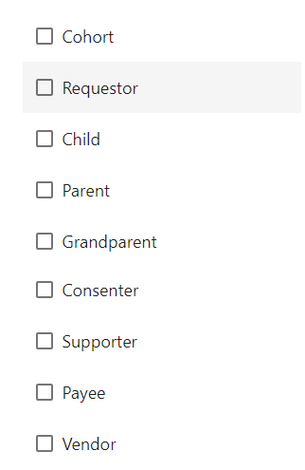
A pop up similar to before will show up. Select whether you are adding a person or an organization and then select the corresponding roles.
Again, it is best practice to use the existing person lookup field to ensure that we do not create duplicates. If a profile already exists, click on the hyperlink to confirm it is the correct person.
When you get to the ‘Contact’ step, you will have to re-search the profile as it does not automatically populate when selecting an existing profile.
If the participant belongs to an organization, fill out the organization step.
If you are adding an organization as a participant, you are able to skip the ‘Person’ and ‘Contact’ stage and fill out the ‘Organization’ section.
List of Selectable Roles

Child Participant
Next we add the Child. Again at the top left corner we press the ‘Participants’ button. Select ‘Child’ as the role. As with the previous participants use an existing profile when applicable, otherwise fill in the information. You will see that when adding a child, two extra steps populate; ‘Origin & Location’ and ‘Needs’.
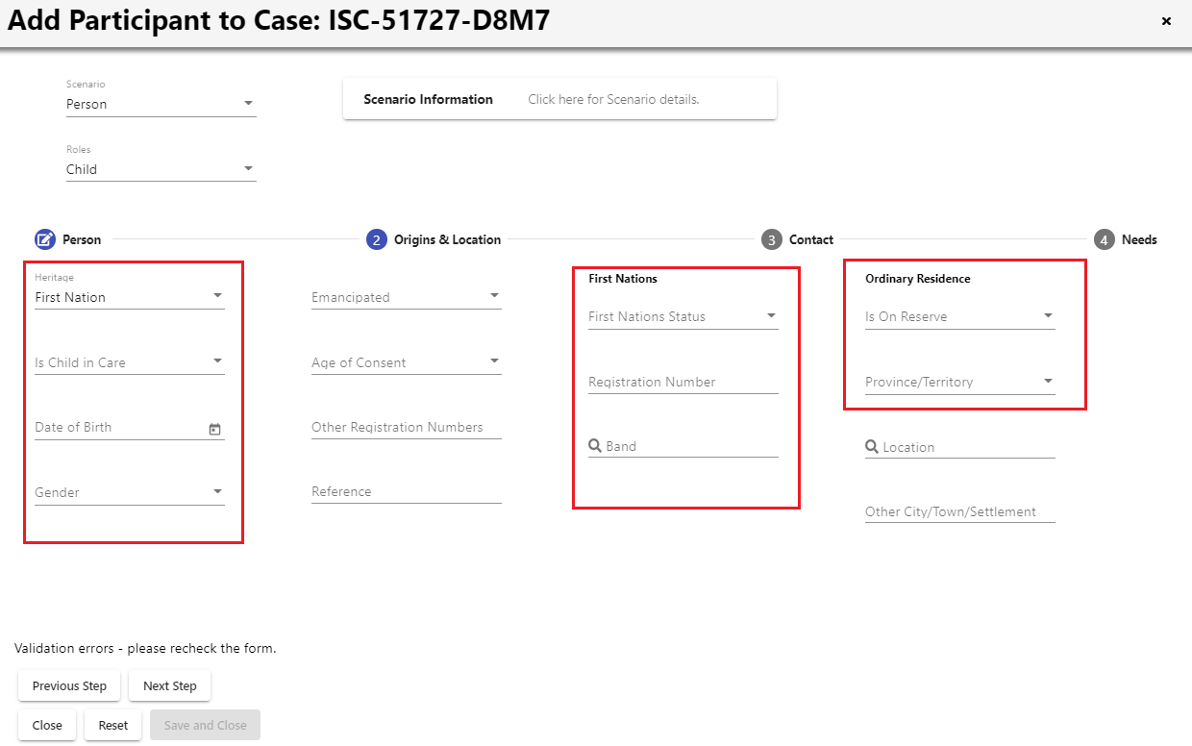
At the Origins & Location step we should try to fill out as much information as possible. Sometimes the incoming request does not provide a lot of information. At minimum, fill out the ‘Province/Territory’ section.

The majority of the information can be found on the request form. Sometimes you may need to look into the supporting documents to fill it out.
Heritage: You have to option to select from ‘Self-Governing First Nation’, First Nation’, ‘Inuit’, ‘Unknown’, and ‘Other.’ The heritage field is mandatory.
Child in Care: If the child is in care, it is almost always provincially funded unless otherwise specified.
Other Registration: We rarely use the “Other Registration Numbers” field. It is for things like FNHA numbers or self-governing First Nation membership numbers. This field is usually left blank.
First Nations Status: Indicate whether the child is registered or not. With use of the Indian Registration System, you can check to see whether the child is 6(1) or 6(2). *If the child does not have status, see the “Note” at the end of this section.
Band: The first 3 digits of the registration number corresponds to their band.
Other Eligibility: Use this field when the child is recognized by their nation. Indicate which band they are recognized by if this information is known.
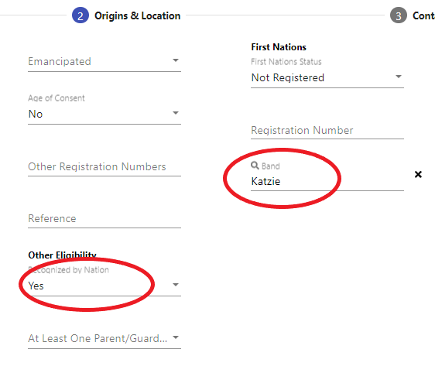

Ordinary Residence: If the child does not live on reserve, select “no”. If they do live on reserve, select “yes”. Province/territory is a mandatory field, and is always BC. If you answered “yes”, try to determine which reserve the child lives on by scanning the request form and/or entering the address in Google Maps. Once you determine their reserve, do NOT use the Location drop down menu. Instead, write the reserve as it is shown in Google Maps in text in the Other City/Town/Settlement box. If you answered “yes” but cannot determine which reserve the child resides on, make note of this in the “Posts” section so the file reviewer knows to follow up.
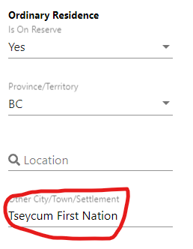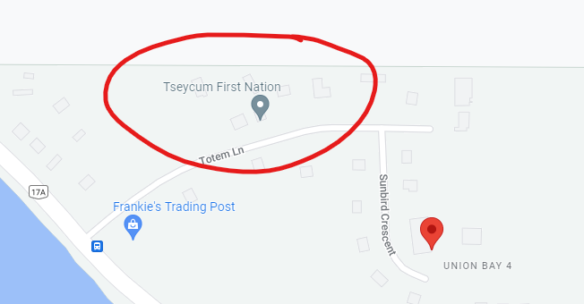

Complete the child’s contact information and include geographic information/address.
Next we add in the needs of the child.
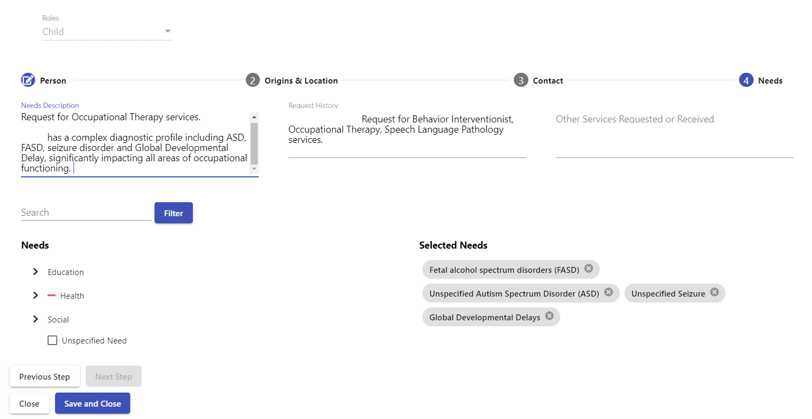
When entering the ‘Needs Description’, try to use the same wording as the requestor. Often the need is specified on the request form, other times you may need to search the supporting documents. The information that is written here follows the child and will auto-populate when a new request is made for them. For this reason, sometimes you do not need to add anything here if the previous request already indicated the same needs (i.e., New request for continuation of approved services).
Since the ‘Needs Description’ from previous cases auto-populates, you can copy and paste it into the ‘Request History’ box if you are inputting a new need.
Next we need to select the needs. Use the ‘Search’ bar to find the needs that correspond to the child. In some cases, the child’s need is specific and you won’t find it listed. In this situation there are broader ‘Unspecified’ categories that are able to be used.
Try to limit the child-item-needs links to the most specific ones relevant to the request, as when we link too many needs GC Case slows down. For example, if the child has dyslexia and ADHD, and the request is for an EA, only indicate the child’s needs as dyslexia and ADHD. Do not also include “Unspecified Education” or “Unspecified Learning Assistance”.
Press ‘Save and Close’ and you should now see the child’s name under ‘Children’.
*NOTE: If the child is not registered but registration information is provided for a parent or other family member, we record the information on the child’s profile a different way. At the ‘Origins & Location’ section, choose “First Nation” as heritage.
After you have created the participant, go back into the child’s participant record. Scroll down to the Heritage form and enter any known information about the parent’s status in the blank data entry field below. Include the relationship (Mother or Father, etc.), their names, their status, and their status number.
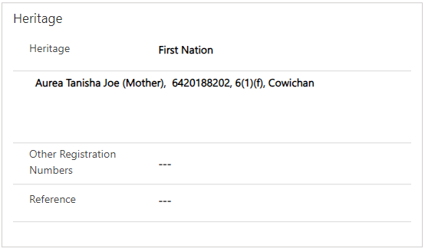

In cases where the requestor indicates that the child’s preferred name differs from the legal name in IRS the shell case officer can make a post in the file indicating the wording/spelling of the preferred name to ensure the correct wording/spelling is used in communication with the requestor.
In all other circumstances, the application version should match what is in IRS. In other words, if the name on the request form appears to be a typo, go with what is in IRS; if a “preferred name” is specifically indicated, use that name in GC Case and document that it is the preferred name in a post.

Items
Items are the products or services that are being requested. The items are often listed in Section 5 of the request form. Sometimes the requestors do not put all the information about their requested products/services on the request form. In those cases, refer to the supporting documents to see if you are able to fill in the gaps.



Begin by pressing the ‘Items’ button on the top left corner.
The following page will pop up: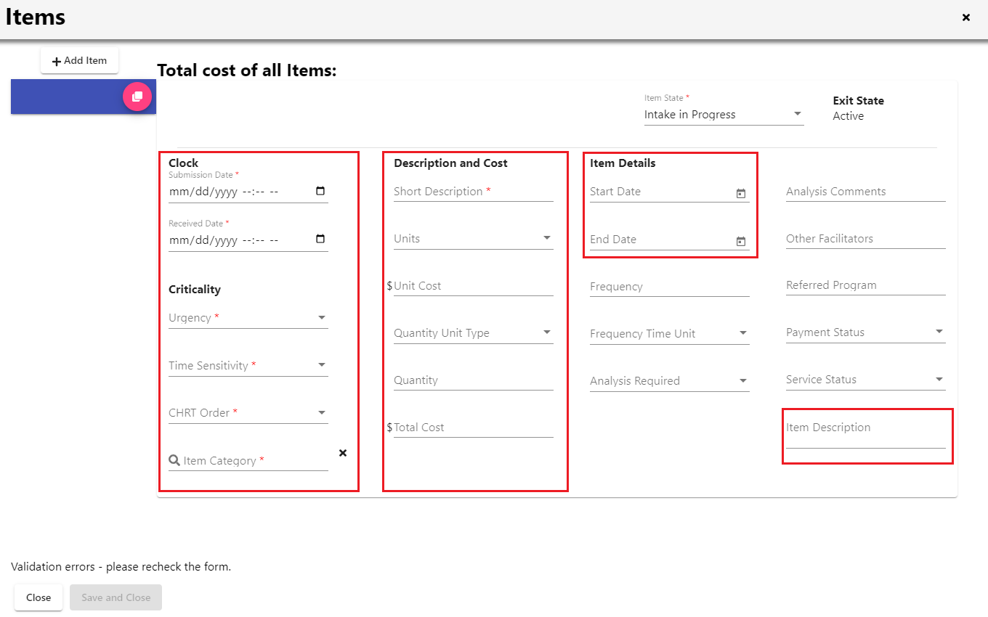
Submitted Date: Refer to request submission date.
Received Date: Refer to request received date.
Urgency: Almost always you will select ‘Non-Urgent’. Do not mark items ‘Urgent’ unless directed to do so by a PM from the Inbox Team. Check first if you are not sure. Note that all Urgent Items will also be Time Sensitive with a target date of 12 hours from the received time.
Priority Urgent: All Urgent items that get directly assigned to a file reviewer must be categorized as Priority Urgent. Priority Urgent items usually align with CHRT guidelines for risk of irremediable harm.
Time Sensitivity: Indicate whether it is ‘Time Sensitive’ or ‘Non-Time Sensitive’ . If it is ‘Time Sensitive’ complete the ‘Target Date’ field that appears below. For Urgent items, they are time sensitive and the Target Date is 12 hours from received time.
CHRT Order: Use ‘N/A’ if the child has status, has a parent who is 6(1), is Inuit, or is from a self-governing First Nation. Choose ‘No Status/Recognized Child’ if the child does not have status but has a parent who is 6(2), or if there is a Band Confirmation Form. Choose ‘Reimbursement’ only if it is for an older reimbursement request from a previous fiscal year.
Short Description: Type in a title that describes the requested product/service. Try to use the same wording as the requestor when possible.
Units: How to quantify the product/service. (i.e., Count, Hourly, Monthly, etc.)
Quantity Unit Type: Indicate if it is a product, service, or support.
Definition - Service: Allied Health practitioner services, all assessments (ie. mental health, education, etc.), medical and/or dental services, mental health counselling, rehabilitation (ie. physical, mental), etc.
Definition – Support: Personnel who will be hired to support a specific child (ie. educational assistant, respite/support/personal care worker, etc), financial support relating to basic needs (food, housing, emergency situation/shelter, natural disaster), cultural and/or spiritual supports (ie. mentor, elder, community event, etc.), transportation and accommodations as related to accessing services, academic supports (ie. tutoring) etc.
Start/End Date: If a date range is indicated you can input it here. Often you may see that no date range is provided, in which case you can feel free to input the fiscal year (April 1st March 31st).
Referred Program: If any participant in the case (requestor, supporter etc) has a school district email, you will need to enter this as the Referred Program in the Item Details. Identify what school district the person works for, their email will look like name@sdxx.bc.ca (example: esmith@sd23.bc.ca).Identify which items are education-related, such as school supplies, Education Assistants, Psych-Ed or ASD assessments, tutoring, etc. ill in the SD number as the Referred Program
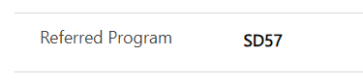

Item Description: Additional information that is relevant to the item (i.e., how many sessions per week, rate breakdown, etc.). NOTE: As of March 1, 2024 we need to include the FA Code, commonly called the Q-Code, in the item description. See Q-Code instructions below.
If you have multiple items to add to the shell case, you can press the pink clone item button on the left hand side. This will create a new item line and copy over everything you filled out, except the submission and received date/time. This saves you some time as you do not have to fill everything out again.
When creating a shell case for multiple children, carefully consider the items. When the item is truly being shared by multiple children, then create one item line and link it to all the children’s needs. If the item can be considered discrete per child, then break it up into one item line per child. If you’re unsure, create one item line and leave it to the file reviewer to break up.
a. Ex: If the request is for one desktop computer that will be shared by three children, create one item line, quantity 1, and link it to the three children’s needs.
b. Ex: If the request is for three children to have one laptop EACH, then create three item lines with each child’s initials (quantity 1 for each item). Then link each item to one of the children.
c. Ex: If the request is for two children to attend tutoring, but they will each have separate sessions, then create two item lines; using their initials to differentiate the items. If they are attending the tutor at the same time to save cost, then they should share an item line. The quantity field would then be the number of tutoring sessions request.
d. EXCEPTION: For travel items, don’t ever break up per child. Leave it up to the file reviewer to break up if necessary, because it can be difficult to know without a deep dive into the request whether or not certain travel items will end up being shared.
Grouping Several Items into One ITM:
For some items that may be listed separately on the request form, it is best practice to group them together into one to support the decisioning and payment process. Items that can be grouped include:
- Furniture
  - Instead of separate items for couch, chair, bedding, bed frame, create one item titled “Furniture”
  - List out the items and known amounts in the long description within the item form
  - Furniture items for separate children can be grouped together into one item; ensure the info is in the long description.
- Dental & Anesthesia
  - These may be listed as separate items, but they can be created as one item with a general title such as “Dental Surgery”
  - Put the cost breakdown in the long description within the item form.
- Assessments and Service Sessions from the same provider
  - An example of this would be a physiotherapy assessment and physiotherapy sessions
  - Create 1 item called something like “Physiotherapy”
  - In the long description within the item form, note the details and cost of the assessment versus the service.
  - EXCEPTION: if there are assessments and service sessions from different service providers, do not lump them together.
  - EXCEPTION: if services are requested for two different children, create separate items (ie Physiotherapy KM, Physiotherapy LM)
Items that Need to be Separated:
Even though they might intuitively go together, please do NOT group the following items together. They must be separate items for payment purposes.
- Formula & Diapers
- Behavioural Consulting & Behavioral Intervention
- School Supplies & Clothing
Add Q-Code to Item Description:
- Look up the item in the detailed resource Item Categories Crosswalk or the general, quick-reference resource Jordan's Principle Financial Administration Q Code Definitions for Shellcase
- Select a button to narrow your search category
- Locate the Tier 3 Item Category with the definition that best fits your item
- Add the Q-Code in the Item Long Description in JPCMS

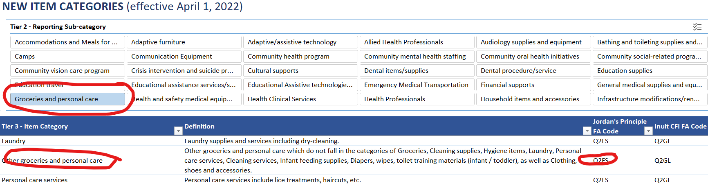

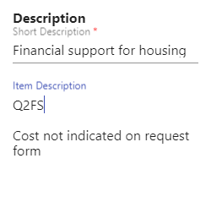

Child-Item-Needs
Now that we have inputted all the items, we link together the child, the items, and their needs. We begin with pressing the ‘Child-Item-Needs’ button on the top left corner.
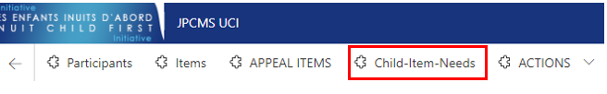
Another pop-up will appear. Read the boxes carefully. First we select the ITEMS that correspond to the CHILD. Then in the secondary boxes that pop up we select the NEEDS that correspond to the ITEM. (Note: you do not need to check all the boxes. Just check the ones that indicate the correct relationship between the child, the item, and the need for the item).
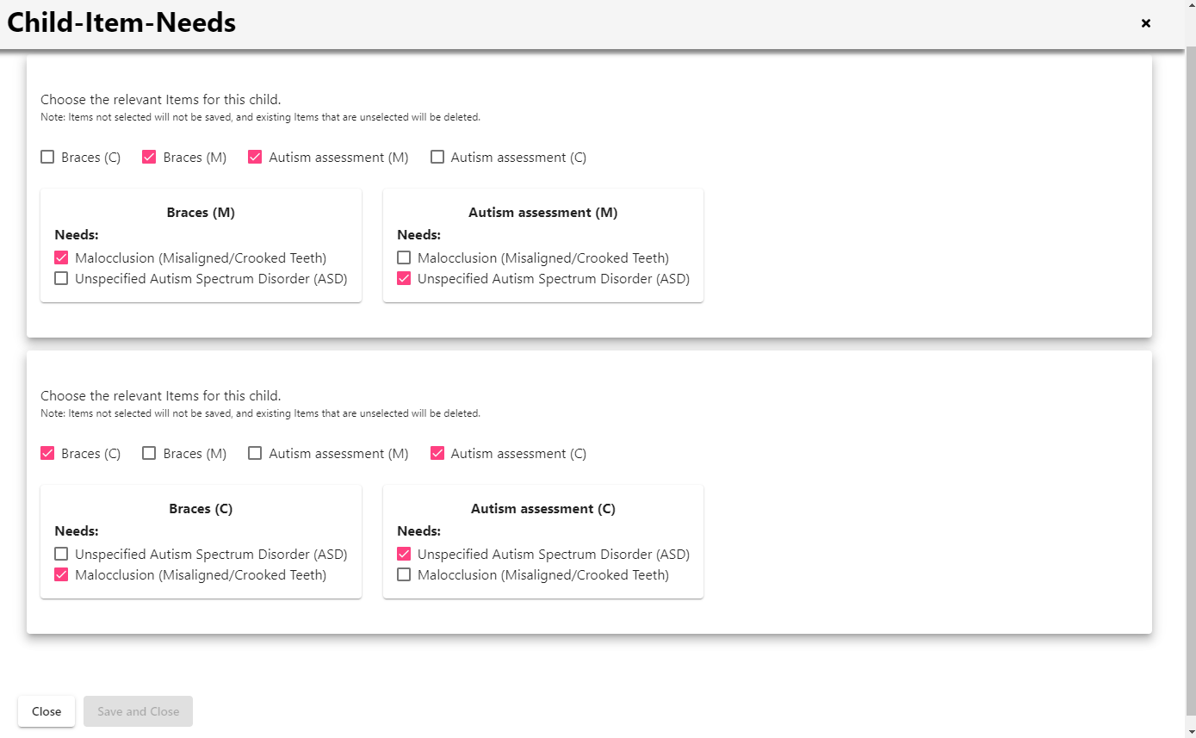

- Sometimes pinpointing a child’s needs is tedious - try your best to match the item to the need
- For example, in this case the child’s need is SLP. We can type “speech” into the search and see what comes up.
I’d personally use “unspecified speech and language impairment” instead of unspecified education, as it speaks more directly to the child’s needs.
You can add this new need and then delete the old one.

Upload Document Package
In the ‘Supporting Documents’ section we upload the PDF package that we created with Foxit. Go to ‘Actions’ and choose ‘New Supporting Doc’.

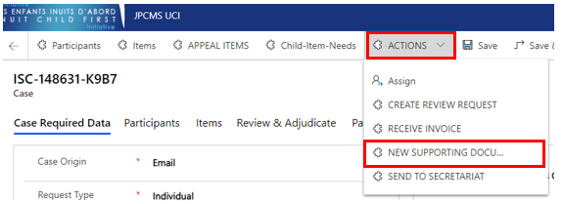

Title the supporting document as: “[Child’s Name] Initial Application Package”.
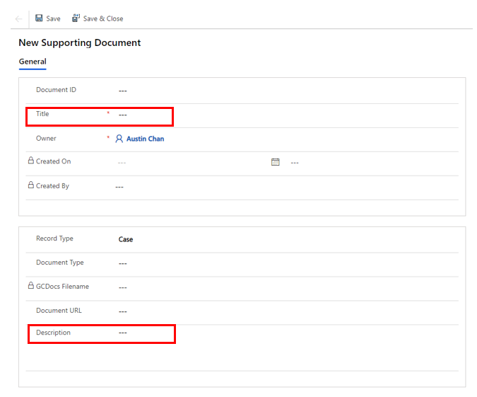
Hit save and a folder icon with ‘GCDOCS’ beside it will appear. Click on the folder icon and upload the initial application package.
If an assessment was included as a supporting document we make a note of that in the supporting document “description” field. Hit “Save” on the top left when complete.

If any payment documents were included with the request, include them in the initial application package AND upload them as separate supporting documents. The file reviewer will send these documents to the payments team to initiate the payments process. Payment documents may include:
- Receipt
- Invoice
- Void cheque
- Direct Deposit form
Payments team prefers that receipts are bundled as one supporting document if it is for the same ITM with a clear title. Invoices/receipts for different ITM #s are to be separated.

Incomplete Request Post

Occasionally we receive incomplete requests. If the request is missing a request form, signature by parent or guardian, letter of recommendation or equivalent document, and/or consent from a parent for an authorized representative (if there is one) the request is considered incomplete. Shell Case will document the missing information, as well as the follow ups completed, in the “Posts” section.

Note that a treatment plan is a sufficient supporting document for dental, and sometimes requestors can provide an assessment rather than a letter of recommendation if it directly recommends the requested support. For more information see “Appendix E – Process for Incomplete Requests”.

Shell Case Post Template for Incomplete Requests - Review and edit/delete the below info as necessary. Copy into a Post.

INCOMPLETE REQUEST
Requestor – Authorized Rep YES/NO
Missing Information:
- Request form
- Eligibility info
- Consent from parent/guardian
- Letter of recommendation or equivalent document
1st Follow Up: completed by Inbox
2nd Follow Up: complete by Shell Case (AOR)

For more information see “Appendix E – Process for Incomplete Requests”.

Assign
We have now inputted all the information required to create a shell case. To finalize the shell case we need to assign the case. In the top right hand corner you will see your name as the owner. Click on the “V” and you will be able to reassign the case elsewhere by removing your name and typing in the new owner.
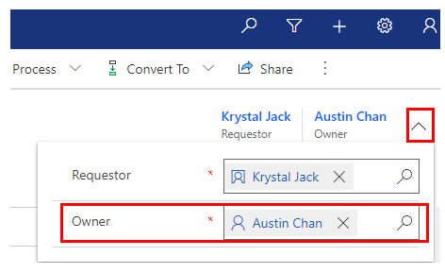
- British Columbia Queue: For most regular requests, you will assign it to the British Columbia Queue. Search for ‘British Columbia Region’
- Urgent: For Urgent requests, you will assign the case to the designated file reviewer. A PM from the Inbox Team will inform you who to assign it to when they send out the Urgent request email.
Congratulations! You have completed a shell case. Now follow the steps to complete an Acknowledgement of Receipt email (see section 3.1), and then return to the New Request Folder to mark the email “read” and change your red flag to “complete”.
NOTE: If you forget to assign the case to British Columbia, it will remain in your personal queue and not show up on any dashboards. Please check your personal queue regularly to ensure you have not forgotten to assign any completed shell cases, and to check that you have not forgotten to complete any in-progress shell cases.
To check your personal queue, look on the left hand sidebar for Requests > Cases.
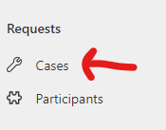
Go up to Active Cases and under System Views choose My Cases. Check the pushpin beside My Cases and it will always show you a list of cases assigned to you whenever you check this view.
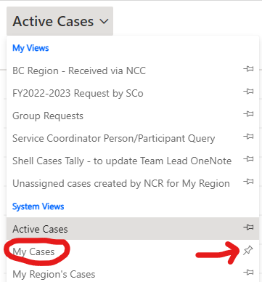

Adding New Items to Existing Pending Cases

As of November 15, 2023, Shell Case officers are encouraged to save data entry and file review time by adding new items to existing pending cases when one is identified in the case history and it is a continuation of services. Training is provided by Deanne Larocque. Please contact her directly with any questions about this process: deanne.larocque@sac-isc.gc.ca

Process:
- When creating an Urgent shell case, check the request history in GC Case
- If there are any existing cases for the child that have items that have not yet received a decision and are related to the current items, add the new Urgent items to that case.
  - If there is more than one case with pending items for the child, add the new urgent items to the case with the newest pending items.
  - A quick way to do this is to look at the ITMs associated with the child’s Person record.
- Add any new information received as part of the new request:
  - Update the Reason for Request
  - Add any new needs
  - Upload new supporting documents
  - Create new items
  - Link new child-item-needs
  - Etc.
- Create a post explaining any new information to help the file reviewer.
  - For example: New Request for dental for child RJ added November 14, 2023 includes a new service coordinator.
- When the update is complete, assign the case to the file reviewer named in the urgent case assignment email.
  - Assign it to the file reviewer associated with the urgent case assignment email even if the existing case is assigned to someone else.
    - For example: the existing case is assigned to PM02 Derrick Robinson. The Urgent item is to be assigned to PM04 Joyce Fan. Update the case and assign the entire thing to Joyce Fan.
- Email the file reviewer that the urgent shell case has been completed and provide the file number.

Considerations:
- Only add items to cases with pending items which have an Item State marked as:
  - Intake in Progress
  - First Contact Attempted
  - Second Contact Attempted
  - Intake complete
  - Review Pending
  - Commitment Pending – only when adding a continuation of service for the same item
- If there are any items in the case that do not meet the above item state criteria, do not add to that case.
  - For example, do not add items to a case that has items which are: approved, escalated, appeal in progress, denied, or suspended.
- If any of the participants are different, please do not add items to that file and create a new file instead.

As of April 16, 2024, this process has been expanded to include adding items to existing files when it is a continuation of service.
Considerations:
- To avoid having extremely large and confusing files, if the file has more than 20 items, please create a new file
- To avoid having outdated information, if the service has stopped for more than two years, please create a new file
- To avoid having requestor’s jumping the queue, unless inbox has indicated who to assign the file to, please reassign the file to the BC Region

Case History: Pending items are appealed/escalated/ suspended etc

Case History
New Urgent Request
Create new shell case
Add new urgent items to existing shell case
Case History: No Pending Items, all have decisions

Case History: Pending Items

GROUP REQUESTS

Along with submitting individual requests, Jordan’s Principle also assesses group requests. Group requests are generally for children from a defined community such as a school or a band, that are not from the same family. As we do not have a standardized group request form at this time, you will have to scan through the request documents to find the required information as best you can.
When the inbox team receives a group request in the general inbox, they move it to the Group Request Folder. Shell Case Team is responsible for prioritizing data entry for the Group Request folder as their first priority after Urgent shell cases. When working in the Group Request Folder, flag the email you are working on. Mark the email as “read” and clear the flag to “complete” when the shell case is created.

NOTE: Please update the Group Request Tracker in GCDocs every time you create a new Group Request.

Creating a group request shell case and follows is similar to creating an individual request (Ref. 2.3 & 2.4) except for a few steps that are different (note – HQ is actively updating guidance about group request data entry processes, ask your trainer/colleague to ensure this info is up to date):
REQUESTOR: Use the name and contact info of the person who submitted the group request. Include their organization.
Required Data
Request Type:
Specific Group for requests of up to 50 children
Estimated Group for requests of 50 or more children
- CMS is too slow to enter 50 or more individual child PRS-IDS
- Create and upload a supporting doc titled Child Participant List_ISC-XXXXXX-XXX
Child Participant
Step 1: Click the ‘Participants’ button. If it is an estimated group of 50 or more children, instead of selecting ‘Child’ as the role, we now select ‘Cohort’ for group requests. Once the dialogue box shown below appears, add all the known information about the case.
In the first column, fill in the number of children according to their heritage. The “Total Children Estimated” will self-populate based on the # of children entered in the fields above. If this information is unknown just put “1” in any of the fields.
In the second column, add information about ordinarily on reserve, registered under the Indian Act, citizen of Self-Governing FN, or beneficiary of LCO if it has been provided.
If you know the children’s birthdates, add their info by age in the third column. You may ignore the fields in the fourth/right hand column: # by location, cohort measurement type, cohort participant info, # of completed assessments.
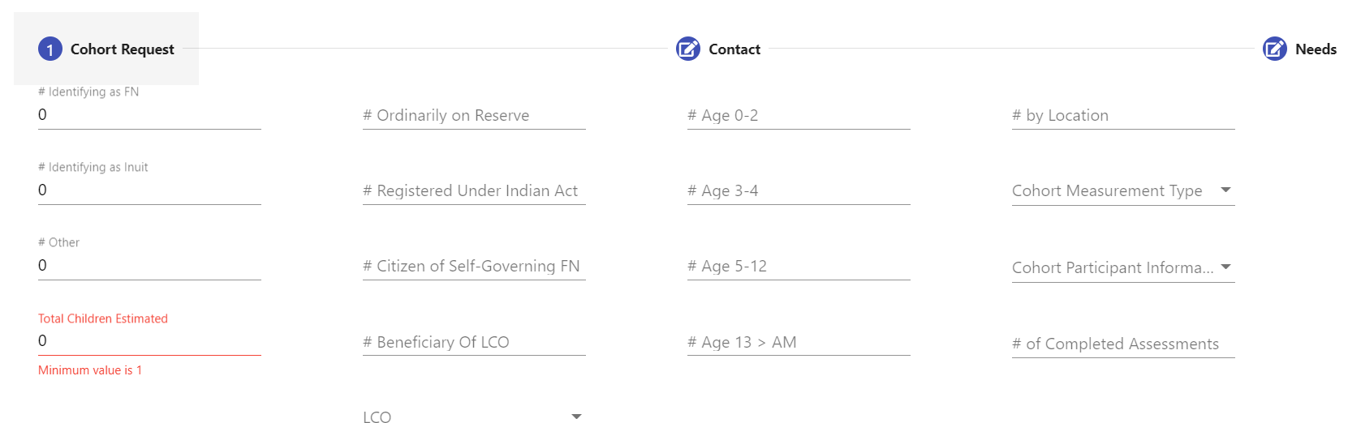
Step 2: Add contact information for the children if you are preparing a specific group request. For an estimated group request we usually add the information of the community/organization the children are associated with instead of for each individual child.
Step 3: The next step requires us to add information about the children’s needs. Fill out the ‘Needs Description’ box with information which is usually specified on the request form, other times you may need to search the supporting documents.
Next we need to select the needs. Use the ‘Search’ bar to find the needs that correspond to the children. In some cases, the needs are specific and you won’t find it listed. In this situation there are broader ‘Unspecified’ categories that are able to be used. Press ‘Save and Close’ and you should now see Cohort 1 under ‘Children’.
PARTICIPANTS: Add any other participants who may be associated with the request. These will most likely be additional requestors or authorized representatives (NOTE: you do not need to add supporters who wrote letters of recommendation or letters of support).
ITEMS: Create the items as they appear on the request form. Sometimes the items are very different from regular shell cases as they are for organizations. Please ensure you add a Target Date. If the Target Date is not obvious from the application, please select a date one month away.
CHILD-ITEM-NEEDS: Link any items to the cohort participant.
SUPPORTING DOCUMENTS: Upload the “Initial Application Package” as normal. If it is an estimated group request for 50 or more children, you must create and upload a supporting document titled Child Participant List_ISC-XXXXXX-XXX
ASSIGN: Assign to British Columbia.
AOR: Send an acknowledgement of receipt email with case number as we would for a regular shell case. Edit the email text as needed to reflect that this is a group request.

NCC REQUESTS
Requestors can contact the Jordan’s Principle National Call Centre and make a request by phone. We do not need a request form for cases submitted via NCC. We do need to complete the acknowledgement of receipt NTF form for each case assigned to BC Region via NCC.
- Shell Case Team needs to look for the NCC Cases that are Urgent and forward the case number to the main Inbox so they can assign it to a file reviewer. Ideally we check for NCC cases about twice a day. Once you send an NCC Urgent to the Inbox, the Inbox officer is responsible to assess it for priority, assign it to a file reviewer if needed, and update the Priority Urgency category in JPCMS if needed.

First we need to locate the cases that NCC has created and assigned to BC Region:
Go to Advanced Find
Look for: Items
Use Saved View: Queued Items Created by NCC for BC Region
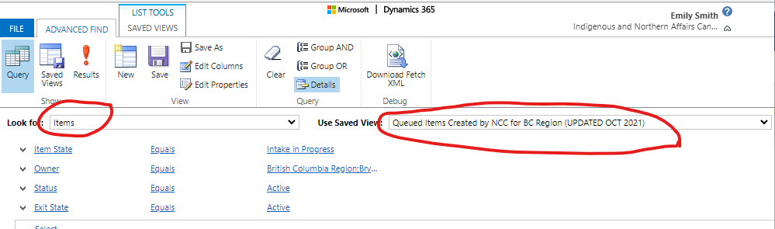
Select the “!Results” button. You will see a list of items organized by case number and sorted by date:
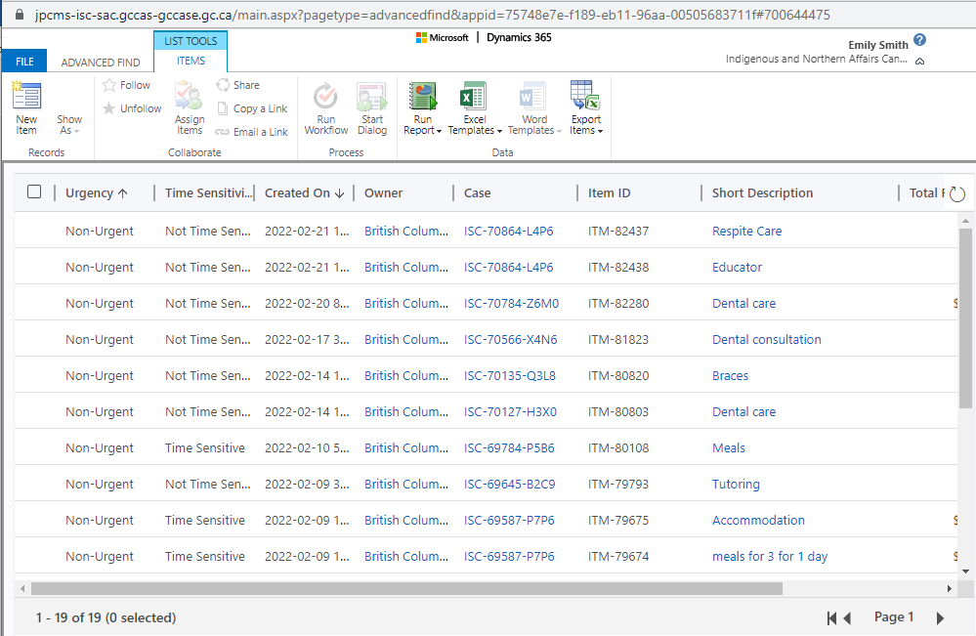

Click on the case number to open the file. Sometimes you will see more than one case number at once, because the case has multiple items.
Check if any items are marked Urgent. If you identify any Urgent items, send an email with the case number to the main Inbox so that the Urgent case can be assigned to a PM04 file reviewer. The file reviewer will perform all follow up needed to obtain supporting documents.
Then go through the list of cases assigned to BC Region by NCC and fill out the Acknowledgement of Receipt NTF form. We will assume that when the requestor called NCC to submit their case, that the NCC officer verbally acknowledged receipt at the time of submission. Your job is to complete the NTF form indicating that the acknowledgement of receipt was provided by phone, and indicate the time and date of the acknowledgement as group similar to or the same as the time the case was submitted.

Acknowledgement of Receipt (AOR)
Shell Case team is responsible for sending a status update to the parent/guardian (and authorized representative if applicable) acknowledging receipt and providing a case number. For the most up-to-date version, please see “Jordan’s Principle Request Status Update” in the Jordan's Principle Email Templates: https://gcdocs.intra.pri/aanc-inac/llisapi.dll/Overview/54362632

Filling out the Acknowledgement of Receipt Notification on GCCase
After you have sent the AOR by e-mail or phone, complete the Acknowledgement of Receipt form on GCCase. Shell Case team does not need to upload the AOR e-mail sent to GCCase.
Follow these steps to complete the NTF:

- Click on “Related” and select “Notifications” from the drop down menu
- Click the NTF number to enter the NTF form
- Click the Actions button at the top left hand corner of your page and Assign the NTF form to yourself, so that you can edit it.
- Then fill out the following three data fields:
  - The Notification Date (is auto-populated with the computer’s best guess. Adjust if necessary)
  - The Participant field (is auto-populated with the requestor’s name. Change if necessary – you will only be able to populate this field with an Adult Participant associated with the request).
  - The Method field – this is the method of communication. Usually you will enter “Email.”
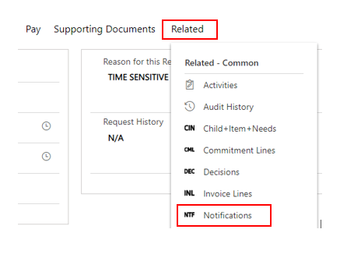
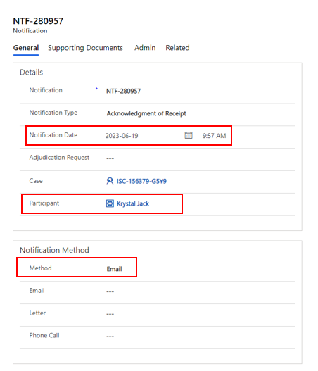
- Once all data fields are filled out, click the Save button in the bottom right hand corner of the screen.
- Then, click the Actions button in the top left hand corner, and choose “Complete.”

Notification of Decisions For ESCALATED CASES

NOTIFYING THE FILE REVIEWERS
Once an case has been escalated to HQ and a decision is made, Shell case team will send a notification of decision of escalation to the Focal Point or Intake officers (aka file reviewers). Someone from Shell case team must check for decision outcomes on escalated cases daily and send out the notification emails.
Refer to the step by step process below to send out the notifications.

HOW TO LOCATE & SEND ESCALATION DECISIONS
In GC Case, go to Advanced Find, the blue funnel on the top right of the home screen.
In Advanced Find look for: Decisions
Use Saved View: Escalated Decisions Made Yesterday
- If you are returning from a weekend or other break where you need to look back further than yesterday, change “Decision Date” to “On or After” the last date you or your co-worker completed
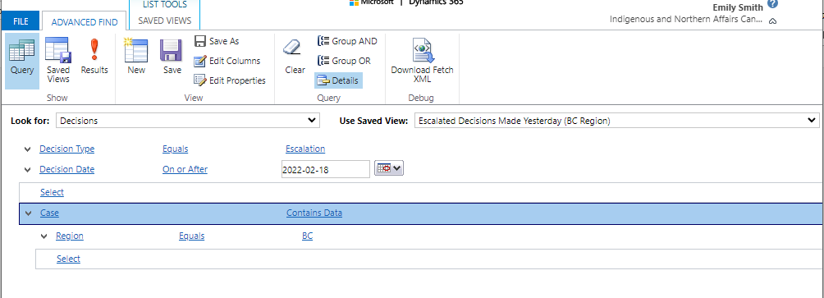

Select “! Results”. You will see the list of cases.
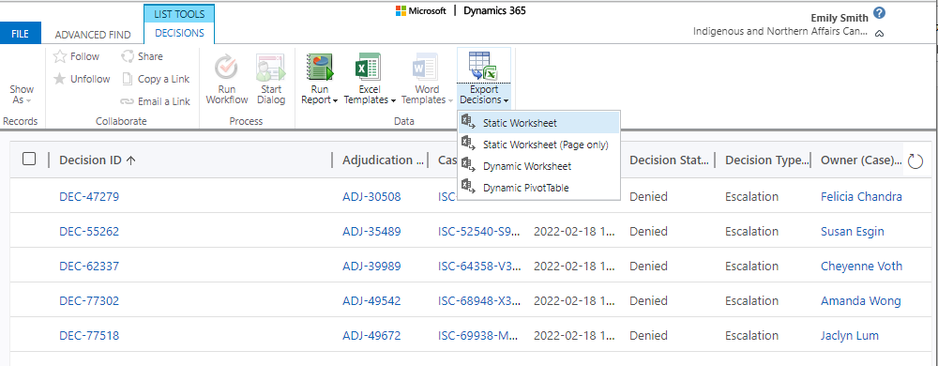
Check which file reviewer is assigned to the case. Create an email and ensure it is sent from the main inbox and CC the policy team. Copy and paste in the ISC#, NTF#, Item name, DEC # and decision (approved/denied). Use the following template:
From: <principedejordancb-bcjordansprinciple@sac-isc.gc.ca>
Subject Line: Decision for Escalated Case ISC-XXXXX
CC: Hyuna & Vanessa
Hello ______________
There has been a decision for escalated case ISC-XXXXX
NTF-XXX for item _________
DEC-XXX
Approved/Denied

Ensure you send an email to each file reviewer for every escalation decision that you find.
If you find an escalation decision returned for a case assigned to a file reviewer who is no longer on the team, send the notification to the main inbox instead.
Keep track of the case numbers you send emails for - if you are on leave, you can let another shell case team member know the last case you notified for so they can take over with no gaps.

Payments

Some shell case officers also support the payment team with creating payment packages. Training is scheduled and delivered by the Payments Team. Refer to the BC Region Jordan’s Principle Payment Manual for more information.

Duty Phone aka Client Support Phone

The Client Support Phone is the general inquiry line for Jordan’s Principle BC Region. The phone number is 778-951-0716. Client Support Phone rotates through a dedicated team on weekdays that is primarily CR04s from Shell Case team; on the weekends, PM04s and PM05s take the phone.
The phone line is call forwarded to your business cell phone on the morning of your shift prior to 8am. Refer to the Client Support Phone Manual for more information.
The schedule is created and uploaded to the Jordan’s Principle General Deskbook on a monthly basis by the person responsible. You can access the Client Support Phone schedule here: Client Support Phone Team Schedule (Web view)
Please ensure that the vacation / leave calendar is up to date with your availability. If you have a scheduling conflict after the monthly schedule has been posted, you are responsible for finding someone to cover your shift(s) and any changes will then need to be communicated to the Scheduler.
When on phone duty, it is important to take notes and add them to the related cases in GCCase. This helps everyone, especially the personnel working on the case stay up to date. This could be done clicking on “Related” then clicking “Activities” from the drop down menu.
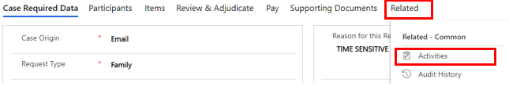

Next click on “New Activity” and then select “Phone Call” from the drop down menu. After, a pop up should appear on the right hand side of your screen. Provide a brief description of the call (i.e., status update, payment inquiry, etc.) in the “Subject” field. Enter who you spoke to in the “Call From” field and their phone number in the “Phone Number” field. Finally, provide a detailed description of the call in the “Description” field. When you are done, select Save and Close at the bottom.
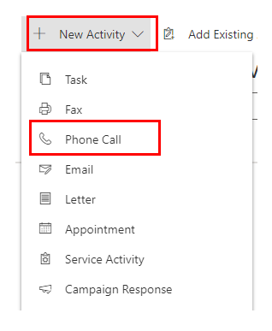

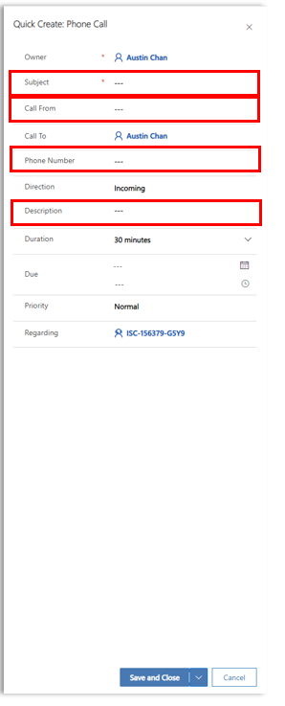

Record the details of the conversation and the who the conversation was held with. Personal information about the case must not be relayed to anyone without the consent. Record the caller’s name and if the call was outgoing or incoming.
When you add a phone call to a specific file we are required to time stamp it by writing “call taken by” “your name” “date & time”. Example: Call taken by Joe Smith 10/26/2021 @2:42pm

Also ensure your voicemail is updated to reflect the duty phone greeting. Use the voicemail script in this document: https://gcdocs.intra.pri/aanc-inac/llisapi.dll/Overview/102581018

For non-urgent calls requiring follow up/action from the payments team please fill out the chart below with the call information. At the end of your duty phone shift please send the completed chart to the payment email inbox paiementsprincipedejordancb-bcjordansprinciplepayments@sac-isc.gc.ca and cc the payments team lead (Rachel Lee, or Bryan Hom if Rachel is away). Rachel and Bryan will help assign the follow up requests to the payment officers the next day. If you receive a call for payments that is urgent. Please send an email in real time directly to the payments team and cc both Rachel and Bryan for immediate action.
Time Call Received | Call Type and Case # | Action Requested of Payments | Requestor’s Contact Information

APPENDIX A – Relevant Hyperlinks

"Jordan's Principle Duty Phone/ On-Call Scheduling and Shift Change Guide”: https://gcdocs.intra.pri/aanc-inac/llisapi.dll/Overview/102581018
Email Templates (includes link to request form: https://gcdocs.intra.pri/aanc-inac/llisapi.dll/Overview/54362632
Jordan’s Principle Link - Submit a request under Jordan's Principle (sac-isc.gc.ca)
Payment Manual - Document Overview: BC Region - Jordan's Principle - Payments Manual.docx (intra.pri)

Appendix B - ISC BC Region Contact Info
In case a requestor needs to provide documentation, but does not have access to email, you can instruct them over the phone to either fax or mail their documents.
Fax number: 604-775-7149
Mailing address:
Indigenous Services Canada, BC Region
Jordan’s Principle Unit
600-1138 Melville St
Vancouver, BC V6E 4S3

If for some reason you need to fax something to a requestor, you can email our mailroom team at bcfilerequests@sac-isc.gc.ca and ask them to send the fax on your behalf. Attach the fax document as a PDF file to your email, and make sure your attachment contains a cover page. Your email to the mailroom team should include:

- The document to be faxed, as a PDF attachment
- The requestor’s fax number
- The requestor’s full name

APPENDIX C: CLIENT SUPPORT PHONE TEAM

The Client Support Phone (aka Duty Phone) is staffed by a weekly rotation of CR04s from the Shell Case Team, as well as 3 members of other teams.
The Client Support Phone Team manages their own scheduling and has their own chat. All resources related to managing the Client Support Phone are linked to from the Duty Phone Manual:
"Duty Phone Manual - BC Region Jordan's Principle - March 28, 2023" can be accessed via the following link: https://gcdocs.intra.pri/aanc-inac/llisapi.dll/Overview/73201956

APPENDIX D – SHELL CASE FROM A FILE REVIEWER’S PERSPECTIVE
Shell Case Presentation by Cheyenne Voth, May 24, 2022

What do file reviewers expect the shell case team to complete?
- Case Required Data and Request History.
- Participant information, as available upon initial application. Includes demographic, foster care, and geographic information. More details on geographic information are discussed below.
- If available, child and parent heritage information.
- List of requested items and amounts, if available.
  - There must be at least one item listed in the case, in order for it to be picked up in a queue.
- Child-item-needs.
- The NTF form for the Acknowledgement of Receipt.
- If there are special things that the file reviewer needs to know or pay attention to, please write a note in the Posts section. Examples:
  - If the child’s status is provided on the request form but can’t be verified in IRS
  - If the child’s DOB on the request form and IRS don’t match
  - If there are multiple spellings of the child’s name
  - If you notice a complex history with the child’s previous requests
  - If consent from a parent/guardian is missing
- Please upload any available documents to the Supporting Documents section, including things like the request form, initial emails, support letters, and your initial follow up for NCC requests.
- The Submitted On and Received On dates. See below for more details.

Submitted On and Received On Dates:
- There are two places that these dates are found: on the Case Summary page, and on each Item Form.
  - The Submitted On and Received On dates on the main Case Summary page are entered only once, by the shell case officer, and do not change even if additional documents are submitted for the case down the road. These dates represent when the first application was received, regardless of whether or not it was complete. These dates may represent when an email was received, a fax was received, or a phone call was taken.
  - The Submission Date and Received Date within the Item Form represents the date that the last piece of information required to make a decision for that particular item was submitted and received. Therefore, these dates often start off the same as the Submitted On and Received On dates on the case summary page, but then can be updated throughout the life cycle of the request, as new information is received.
  - Submission dates = time stamp of the email, fax, or phone call.
  - Received dates = when the case or item was created in JPCMS. Therefore the Received dates must ALWAYS be equal to or after the Submission dates.
- Anyone uploading supporting documents will update the Submitted & Received On Dates within the Item Forms if they are the ones uploading additional supporting documents after the shell case team has created the initial request in GCCase.
Target Dates:
After the last major GCCase update, SIA introduced the new “Target Date” fields in the Item Forms. These date fields become mandatory when an item is marked as time sensitive or urgent. Usually, a shell case member will fill out this field, but it may also need to be filled out by file reviewers, if the item is originally marked as non-time-sensitive, but becomes time sensitive later on. We have not received clear instruction regarding how to use the Target Date field, and at the last Super User meeting, SIA said they are still working with HQ to come up a guide/instructions to be sent out to all regions, so for now, let’s use the following definition so that we can at least be consistent with each other in BC:
- Target dates only need to be filled in for urgent or T/S requests.
- The target date is an estimate of when the item is needed by (basically, this date backs up the claim that the item is T/S or urgent, and also helps people identify which T/S is the highest priority).
- The target date will be used to order T/S and urgent items by priority, but does not affect the “clock” (ie, it won’t affect our compliance with CHRT-mandated timelines). It is understood that this date is an estimate, or best guess.
- Sometimes, a target date will be an easily identifiable, specific date. For example, if a request is identified as T/S because it’s for travel for an appointment occurring on March 10, 2022, then the target date is March 10, 2022. Or, if the request is T/S because the service provider says they will withdraw services if payment isn’t received by March 30, 2022, then the target date is March 30, 2022.
- Other times, the target date is more vague and harder to define. For example, perhaps the request is T/S because the family needs rent paid “as soon as possible,” because they’re facing eviction. Then you need to use judgement – perhaps the end of the week should be the target date. Or the child needs approval for an urgently needed medication – then perhaps today or tomorrow should be the target date.

Adding Participants:
- When adding a Participant to a case, please remember to ALWAYS check if the Participant already exists. We want to avoid duplicate Participant/Person entries. Some tips to checking for already-existing Participants:
  - If the name is spelled in an uncommon or tricky way, try searching for variations on the spelling.
  - If the person goes by a shortened form of their name, search both their full name and shortened name (ex. If their name is Kimberly, but they always sign off as “Kim,” search both names)
  - Search the last name by itself to see if you get any hits.
  - If you search a name and get a match, check their address and other details to try and determine whether it’s the right person, or a different person who has the same name.
  - Same principles apply for search for duplicate Organizations. Search keywords instead of the full Organization name. (ex. If you are entering the Organization “Lothlorien Pharmacy Ltd.” consider just searching for “Lothlorien” and “Lotholorien Pharmacy” – don’t include the “Ltd” part in your search, in case someone entered this organization without that part. Or maybe a previous person entered the organization as “Lothlorien Pharmacy Limited” or “Lothlorien Pharmacy Inc.”
- As much as possible, add geographic and contact information for Person and Organization Participants, to help future officers identify potential duplicate participants.
- As much as possible, link Person Participants to Organizations when relevant. For example, if the requestor is a member of a Delegated Aboriginal Agency, this is important to know, so they should have the DAA organization information filled out in the Participant form.
- If you are missing important information for a Participant in the file (for example, the child’s address is missing, or you don’t know if they live on reserve or not), consider writing a note in the Posts section to alert the file reviewer that they will need to follow up for this information.

Geographic/Location Data:
- There are a LOT of places to enter location data, so it can become confusing.
- First of all, note that there are three key geographic locations that we are interested in:
  - Where does the child live? (Their home address)
  - If the child lives on reserve, which reserve is it?
  - What is location of the service coordinator or Delegated Aboriginal Agency (DAA) associated with this request?
- Where does the child live (their home address):
  - Up until now, we have been entering this information in two places: The child’s Contact Details, AND their Location of Residence information:
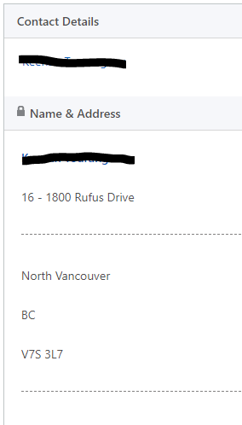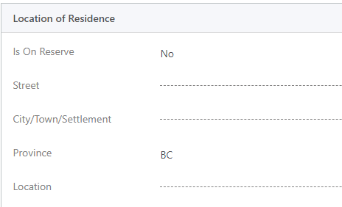
  - Going forward, we ask that the child’s home address information only be included on the Contact Details form.
- If the child lives on reserve, which reserve is it? Going forward, we ask that you use the Location of Residence section to enter this data. The “City/Town/Settlement” field is a free-field in which you can type the name of the Band reserve that the child lives. This field only needs to be filled in if the child lives on-reserve. If the child lives off-reserve, it’s expected that these fields will be blank. The “Location” field is a drop-down that should be filled to the best of your ability if the child lives on reserve.
  - You may not always have this information, at the shell case stage. If the child lives on reserve, but you don’t know which reserve, it will be up to the file reviewer to fill in the missing data. If necessary, simply indicate “Yes” for the “Is On Reserve” field, and leave the rest for the file reviewer.
- What is location of the service coordinator or Delegated Aboriginal Agency (DAA) associated with this request? We care about this information for reporting purposes. We want to be able to pull a reports for a list of all requests associated with a particular service coordinator, or associated with a particular DAA.
  - Right now, we know that Participants can only be identified as Service Coordinators if they are the initial Requestor indicated at the start of a new request. I have emailed an SIA representative to ask if this can be changed, so that we can enter Service Coordinator data throughout the life cycle of the request.
  - In the meantime, it is important that if a Service Coordinator or DAA representative is entered as any kind of Participant, they are linked to their relevant organization. And this organization data should include the geographic information.
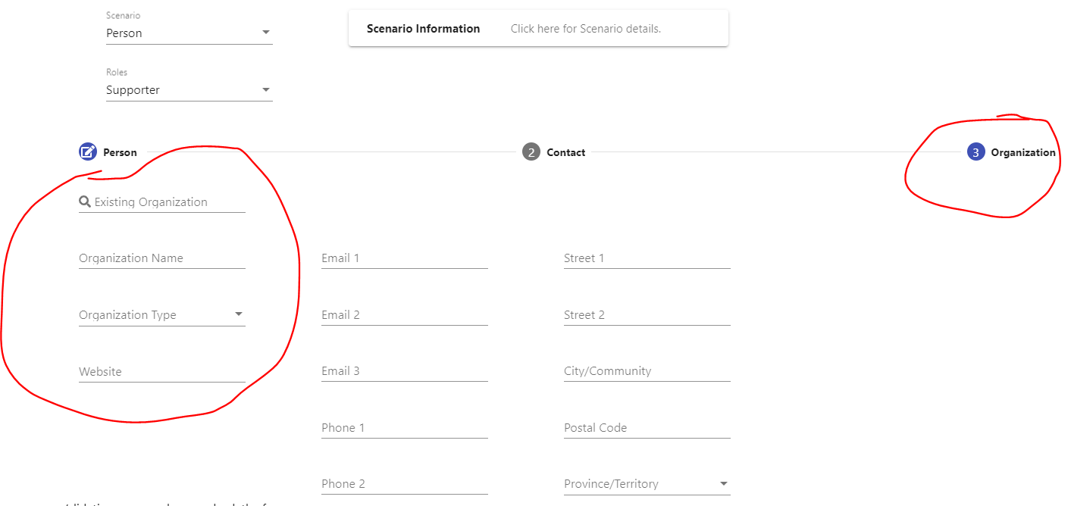
- In summary:
Information about the child’s home address is entered here:
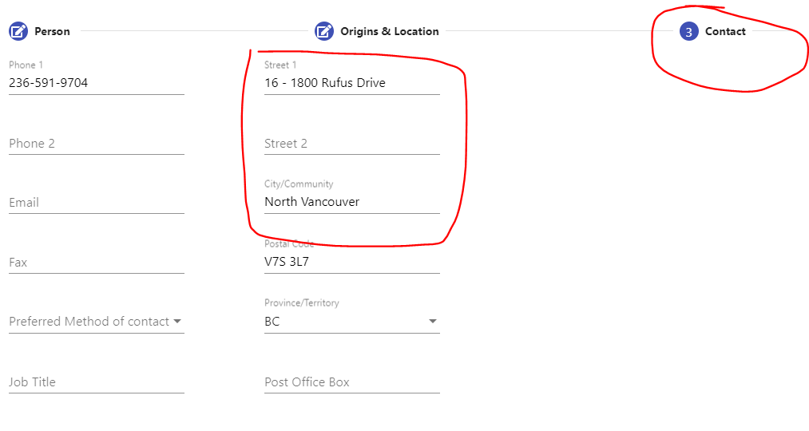
Information about the reserve that the child lives on is entered here:
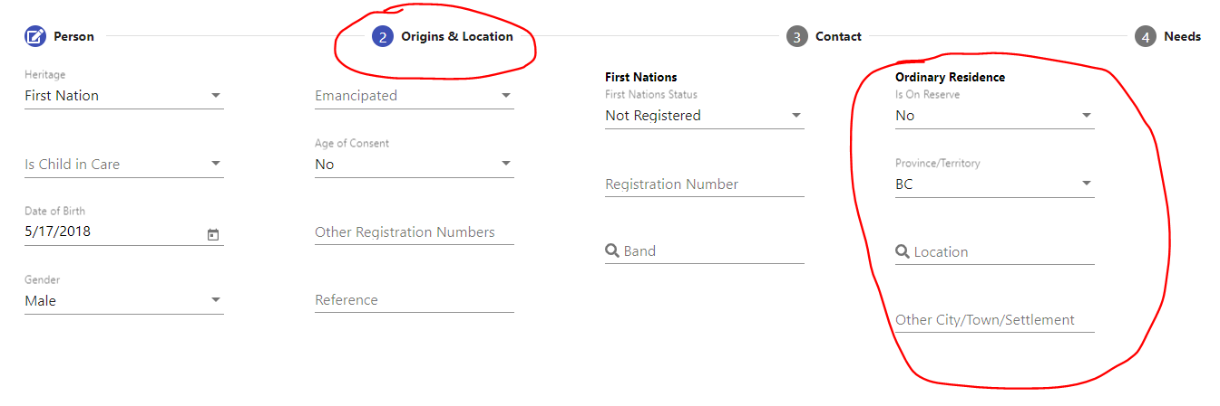
New Requests vs Extending Existing Requests:
- Think about:
  - What is the easiest way to view the information?
  - What is the easiest way to organize the payments?
  - How inextricably linked are the new items to the old items?
  - Are the new items replacing old items, or just adding additional funds?
- Generally speaking, a new request should be created if:
  - The new item is discretely definable, with its own start and end date, and is not inextricably linked to an existing request.
  - There is no overlap with an existing request.
  - The new item has been born out of new information / documentation / communication that wasn’t available when the original item/request was created.
- Generally speaking, a new item should be added to an existing request if:
  - If would cause considerable hardship to transfer information from the old request to the new request.
  - The new item is closely linked to an existing request.
    - Ex. An existing request for ferry and taxi has been approved. Then, the parent comes back an also asks for hotel accommodations related to the same travel itinerary. Add the hotel item to the existing request.
  - The new item is an overage for an existing request.
  - The new item is replacing an existing item.
- If adding a new item to an existing request, please notify the original File Reviewer.
- If creating a new request, it can go to the general queue. Exception: if the request was complicated – then notify the original file reviewer for the purposes of efficiency.

Some Other Questions to Consider:
- Can old suspended items be reanimated/resumed? Yes. There is no time limit. Do not create duplicate requests.
- Reminder: we have a naming convention for EA requests:
  - Use the following naming convention for the Item Name in GCCase (aka the “short description” on the Item Form). Choose from the following three options:
    - EA – SD## (for example, EA – SD52) <-- for public schools
    - EA – Private School
    - EA – On-Reserve School
- Can we ask SIA to make “Authorized Representative” a Participant role type?
  - Cheyenne to ask SIA.

Appendix E - Process for Incomplete Requests

Summary
- If an incomplete request is received, ISC will perform a total of 3 follow ups before the request is put into suspension.
  - First: Intake
  - Second: Shell case
  - Third: File reviewer
  - Final step will be for file reviewer to put request into suspension by following standard suspension procedure.
- All attempts documented in GC Case posts. One of the three these attempts needs to be a phone call
- Overview of steps to take when an application is submitted by a requestor who does not have consent and no contact included of the parent /guardian in the documents.

Step 1: Intake responsibility

Time line: Follow up done when the application is received

- Receive the request and determine what information is missing
  - (eligibility information, request form, consent, letter of recommendation, etc.)
- Send initial follow up to the requestor asking for the missing information by email or phone, dependent on what information is provided
  - If consent is not clear, try your best to contact the family if contact information is provided
- Place the incoming request into the "New Request Folder" under the General Inbox
  - Include the initial follow up email. Also confirm that you have followed up for the missing information and list the information still missing.
- If any subsequent responses come in, move to "New Request Folder" and colour code with the original request
- If response is received after the case is created, upload the email to GCCase

Step 2: Shell Case responsibility

Time line: dependent on the "New Request Folder" queue, currently ~10 business days
Shell Case will create an "incomplete shell case" in GCCase in order to generate a file number
- All previous correspondence will be included within the "Complete File" that is uploaded to every case
- Send out the Acknowledgement of Receipt (AoR) email to the requestor and mark as complete.
- SCENARIO: If the request came from someone outside of parental guardianship (i.e., doctor, teacher, etc.) and the parent’s contact information is not provided, the AoR can still be sent to them as it only includes the file number and no other personal information. The AoR should also clearly indicate that the file is incomplete as it requires parental consent in order to process the request.
  - Shell Case will make a Post indicating that the request is incomplete. They will also include that the inbox has followed up asking for further information and Shell Case has followed up via the AoR.
  - The post will also clarify what is still missing and if the submitting individual has consent to be given more information (in the case of a non-guardian submitting the request)
- Shell Case to assign the file into its respective queue (PM-04, PM-05, PM-02)
File Reviewer responsibility

- File reviewer to assign themselves the incomplete file from the queue as usual.
- File reviewer to check the Post section in order to determine how many follow ups have been made and what information has been provided
- If responses have been received between the time of case creation and getting assigned, they will be attached as Supporting Documents
- File reviewer's initial follow up will be considered the Third Attempt. After sending out the third follow up, the file reviewer can push the item state to suspended.
- 1st attempt coming from Inbox follow up
- 2nd attempt coming via AoR from Shell Case
- If none of the previous attempts were indicated as a phone call to the requestor, the File Reviewer's final follow up attempt will be by phone

- If the final follow up is by phone, the File Reviewer will send out an email to the requestor notifying suspension and informing them that they may re-activate the request by submitting the required information.

APPENDIX F – How to Exit Items and other Superuser Processes

Sometimes we need to remove information from a case. Maybe we created unnecessary items and saved by accident, perhaps we uploaded an incorrect supporting document, or we might realize we have created a duplicate person participant.
Compose an email to your GC Case Superuser: List of BC GCCase Super Users (Web view) and include the following info:
- Case number
- ITM-/DOC-/PRS- ID number of what you need to exit
- One sentence rationale explaining why
- Name or title of the item/supporting document/participant

EXAMPLE 1
a. ISC-45886-T0J6
b. ITM-28510 & ITM-98180
c. I was originally directed to add these items to an existing shell case but later directed to create a new shell case. Items are to be deleted from existing case.
d. Items are named DELETE

EXAMPLE 2
a. ISC-86969-H7V6
b. DOC-626799
c. PDF saved accidentally with documents out of order.
d. Supporting doc is named Grayson Edwards Complete file, status is “inactive”

Remember, to find the ID number of what you would like to exit, click on the hyperlink of its name and then look in the top of the “General” info box.

